

**Mega International Commercial Bank New York Branch**

SWIFT Network

**Compliance Data Mapping Document**

Version: 1.0

Effective Date: XX/XX/XX

**Revision History**

|  |  |  |  |  |
| --- | --- | --- | --- | --- |
| **Date** | **Version** | **Status** | **Prepared By** | **Comments** |
| January 16th, 2020 | 0.1 | Draft | Lulu Guo | Initial Draft |
| February 21st, 2020 | 1.0 | Final | Lulu Guo | Version 1 |
|  |  |  |  |  |
|  |  |  |  |  |
|  |  |  |  |  |
|  |  |  |  |  |

**Document Control**

|  |  |  |  |
| --- | --- | --- | --- |
| **Function** | **Name** | **Authority** | **Date** |
| AML & Sanctions Technology Officer | Narciso Barte |  |  |
| Compliance Program Officer | Brendan Strang |  |  |
| Chief Compliance Officer | Sharon Farrell |  |  |

Contents

**I.** **Introduction** 4

**II.** **Assumptions and Limitations** 4

**III.** **Master Data Flow** 5

**a.** **4 systems** 5

**b.** **Message Types** 6

**IV.** **Sanction Screening Data Flow** 8

**V.** **Transaction Monitoring- BSA Reporter** 15

**VI.** **eGIFTS** 17

**a.** **Wire Transaction Data Mapping to eGifts** 17

i. **CHIPS and eGIFTS** 17

ii. **FedWire and eGIFTS** 19

iii. **SWIFT and eGIFTS** 19

**b.** **Data Mapping from eGIFTS to PRIME (OFAC Reporter)** 21

**c.** **Data Mapping from eGIFTS to AS400** 25

**VII.** **SWALLOW** 28

**a.** **SWIFT and SWALLOW** 29

**b.** **SWALLOW and PRIME** 29

**c.** **SWALLOW and AS400** 31

**VIII.** **AS400/ PRIME** 32

**a.** **AS400 to PRIME Data Mapping** 32

**IX.** **Appendix** 38

**a.** **Assumptions and Limitations** 38

**b.** **Sanction Screening Data Flow** 38

**c.** **Transaction Monitoring Data Flow** 38

**d.** **eGIFTS** 38

**e.** **Swallow** 39

**f.** **AS400/PRIME** 39

1. **Introduction**

The document will describe data flow and individual data mapping among all AML systems and transaction types at Mega International Commercial Bank New York Branch (“Mega NYB”). The data mapping document is a process of mapping data fields from a source file to their related target fields. It will focus on the critical data elements pertaining to compliance in eGIFTS, SWALLOW, AS400, and PRIME.

This document will provide details on Sanction screening data flow and BSA/AML data flow. It will also include distinct mapping for the following:

1. SWIFT, FedWire, and CHIPS to eGIFTS
2. eGIFTS to PRIME OFAC Reporter
3. eGIFTS to AS400
4. SWALLOW to PRIME OFAC Reporter
5. AS400 to PRIME

The Compliance Data Mapping Document will be maintained by the Branch’s AML and Sanctions Technology Team. Changes made to this document should be governed by the Branch’s Compliance Change Management Procedures.

1. **Assumptions and Limitations**
   1. **Assumptions**
      1. Wire data (SWIFT/FED/CHIPS) is transferred through pre-defined free format streams, mostly by MQ or text file among SWIFT NET, Swallow, eGifts, and AS/400. Only Prime BSA Reporter and OFAC Batch Filter accept landing files in tsv format. Thus, additional effort is needed comparing different tags with table fields in contrast to standardized table to table mapping.
      2. Vendor of eGifts and Prime, FIS (Fidelity Information Service), could not provide official data dictionary as well as the mapping logic of internal operations on its system(s). Thus, this document focuses on Compliance Anti-money Laundering related data elements for scenario design, and the mapping logic is inferred by Mega bank through existing materials used for reference only.
      3. KYC data elements will not be specifically cited as they are already included in the customer files of PRIME BSA Reporter.
   2. **Limitations**
      1. The number of fields and its length is limited in PRIME BSA Reporter, please refer to the specification document for limitation details.
      2. Based on the Inclusion/Exclusion analysis, the scope of the monitoring within the Prime environment was defined.
      3. The document is limited to the existing materials provided by system vendors and testing performed by the bank.
         1. Due to limited information on eGifts system, this mapping applies to available records related to eGifts.
2. **Master Data Flow**

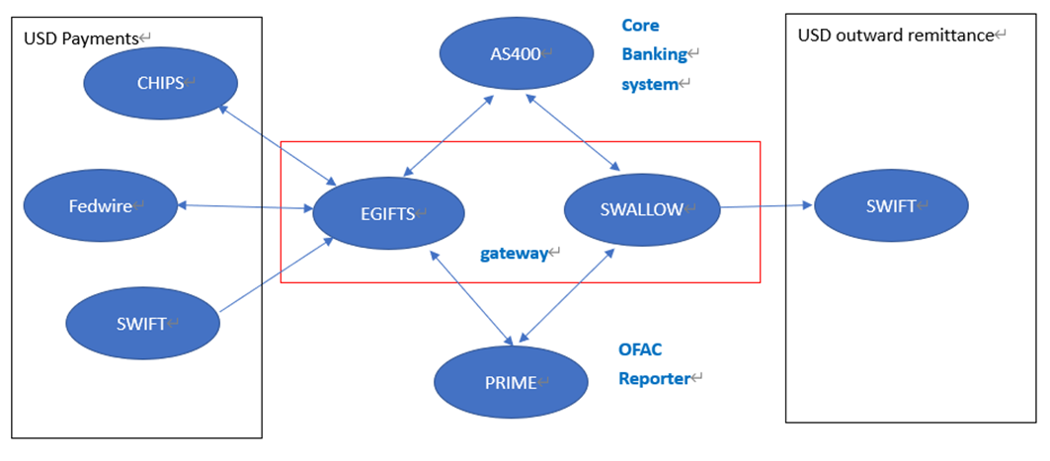

*Figure 1: Illustration of the Wire Flow among all Systems*

* 1. **4 systems** 
     1. **eGIFTS** (Enhanced Integrated Funds and Telecommunication System)
        1. A front-end system and a gateway between FEDWIRE, CHIPS, SWIFT, OFAC Reporter (PRIME) and our core banking system (AS400).
           1. All incoming USD SWIFT payments are sent to eGIFTS for processing (MT103, MT200, MT202, MT202COV, MT203)
           2. All incoming FEDWIRE and CHIPS payments are sent to eGIFTS for processing.
     2. **SWALLOW**
        1. A front-end system and gateway between SWIFT, PRIME OFAC Reporter and AS400.
           1. Incoming non-USD SWIFT payments are sent to Swallow for processing (MT103, MT202OV).
           2. Incoming non-payments SWIFT message are sent to Swallow for processing (MT199, MT299, MT700, MT701, MT705, MT707, MT740, MT756, MT799).
           3. Outgoing SWIFT payments are processed through Swallow.
     3. **Overseas Branch System OBS AS400**
        1. Mega NYB’s core banking system and our source system.
           1. Its Application Server processes both incoming and outgoing transactions, US Dollar payment for NYB customers. Additionally, the system originates transactional flows, customer information flows, and account information flows to Prime.
     4. **PRIME**
        1. Mega NYB uses PRIME as a single, comprehensive, integrated solution for AML compliance, sanctions monitoring and transaction surveillance. It uses transactional activity, customer and account tables as part of its monitoring process of reviewing transactional flow, customer information flows, and account information flows from AS400.
           1. RPIME OFAC Reporter is used for sanction screening.
           2. PRIME BSA Reporter is used for transaction monitoring.
  2. **Message Types**

There are three kinds of messages used at Mega NYB, SWIFT, FedWire and CHIPS.

* + 1. **SWIFT-** (Society for Worldwide Interbank Financial Telecommunications) is an international bank messaging system used to instruct a bank to transfer funds from a specific account to a specified account at another bank. The SWIFT network provides the information for wire transfers though the actual payment flows from the originating central bank to the Federal Reserve, CHIPS or potentially your own SWIFT recipient bank.
    2. **Fed, or Fedwire-** (Federal Reserve Funds Service) is operated by the Federal Reserve banks. The Federal Reserve’s funds transfer system is used by member banks and other depository financial institutions to electronically transfer funds between its participants.
    3. **CHIPS-** (Clearinghouse Interbank Payments System) is a private network that also handles international wire transfers and is both a customer and competitor to Fedwire. Final settlements are made by banks using CHIPS and maintaining accounts at the New York Federal Reserve Bank.

Incoming wires enter via Swift, FedWire, and CHIPS and process through eGIFTS/Swallow. While processing in eGIFTS/Swallow and prior to transmission, the messages are scanned in PRIME OFAC Reporter for Sanction screening purposes. Once cleared in PRIME, the funds are then sent out via Fedwire or CHIPS.

Outgoing wires initiated by the New York Branch are input into AS400 and processed via eGIFTS or Swallow. eGIFTS and Swallow will then automatically transmit the data to PRIME for OFAC screening prior to onward transmission via FedWire, CHIPS, or SWIFT. (Please refer to Figure 1).

1. **Sanction Screening Data Flow**

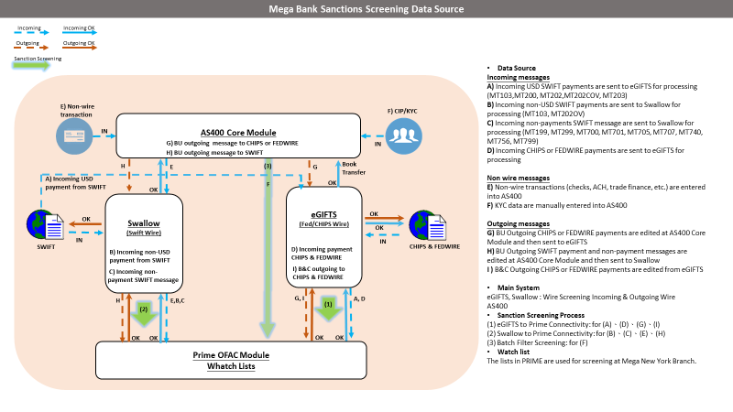

*Figure 2: Illustration of Mega Bank Sanctions Screening Data Flow*

* + 1. **Incoming SWIFT USD payment messages to Mega NYB**
       1. SWIFT USD payment messages to Mega NYBB will automatically be transferred to the eGIFTS system. Then, these messages will be automatically screened through OFAC reporter (PRIME). When a USD payment message is screened and deemed clear of any sanctions-related issues, it is either paid to other Financial institution by FedWire/CHIPS or payment is to debited or credited to the customer’s account in Mega NYB (Book Transfer to AS400).

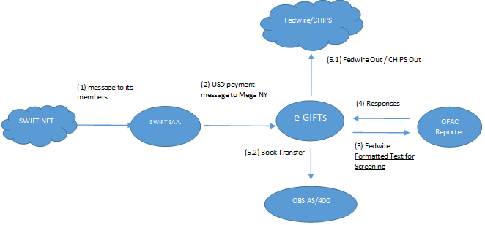

*Figure 3: Illustration of USD payment message from SWIFT Network to NY Branch*

Please refer to the following 5 step process based on Figure 3:

**(Step 1)** SWIFT Net sends out SWIFT messages to Mega NYB’s SWIFT Alliance Access (SAA). It is predefined by SWIFT as its internal connection to every member. Thus, Mega NYB cannot change any message forms or data in this stage since it is controlled by SWIFT, the organization that provides global financial messages.

**(Step 2)** Once SWIFT SAA. receives a payment message, a duplicate message would be delivered to eGIFTS with original SWIFT text for wire room to proceed with the transaction.

**(Step 3)** eGIFTS would parse the message text into Fedwire format, and send it to PRIME OFAC Reporter for Sanction screening.

**(Step 4)** Screening or investigated results will be returned to eGIFTS to determine the next step of the flow. If the message is not hit or hit but waived by the OFAC Reporter, eGIFTS will get the message that the wire could proceed its flow. If the message is hit, then eGIFTS will instruct wire room staff to stop the payment.

**(Step 5)** When a USD payment message is screened through Prime OFAC reporter and deemed clear of any sanctions-related issues. A message will be:

**(5.1)** Paid to other Financial institution by FEDWIRE/CHIPS. (FEDWIRE OUT/CHIPS OUT)

**(5.2)** Debited or credited to the customer’s account in Mega NYB. (Book Transfer)

* + 1. **Incoming FedWire and CHIPS payment messages to Mega NYB**

The process of payment messages from Fedwire/CHIPS is illustrated below.

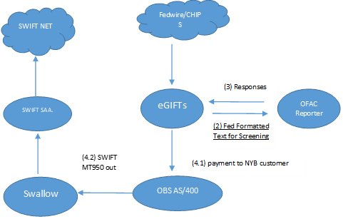

*Figure 4: Illustration of USD payment message from FedWire and CHIPS to NY Branch*

**(Step 1)** CHIPS or Fedwire payment messages are sent to eGIFTS for wire processing.

**(Step 2)** eGIFTS would parse the message text into Fedwire format and send it to PRIME OFAC Reporter for screening.

**(Step 3)** Screening or investigated results will be returned to eGIFTS for the next step of the flow process. For example, when the message is not hit or hit but waived by OFAC Reporter, eGIFTS will get the message that the wire can proceed its flow, or eGIFTS will instruct wire room staff to stop the payment if there is a true hit.

**(Step 4)** When a USD payment message is screened through Prime OFAC reporter and deemed clear of any sanctions-related issues. A message will be:

**(4.1)** Payment to NYB customer

**(4.2)** If NYB customer is a correspondent bank, then at the end of the day, NYB will send the SWIFT statement message MT950 to the correspondent bank.

* + 1. **Outgoing payment messages from Mega NYB to SWIFTS, FedWire, and CHIPS**

SWIFT/CHIPS/Fedwire message will be generated from Mega NYB’s core banking system OBS AS400. SWIFT messages will be sent through Swallow to SWIFT NET for USD international payments. Fedwire/CHIPS message will be sent through eGifts to CHIPS and Fedwire for NY USD and domestic payment. All message is sent to OFAC Reporter for screening.

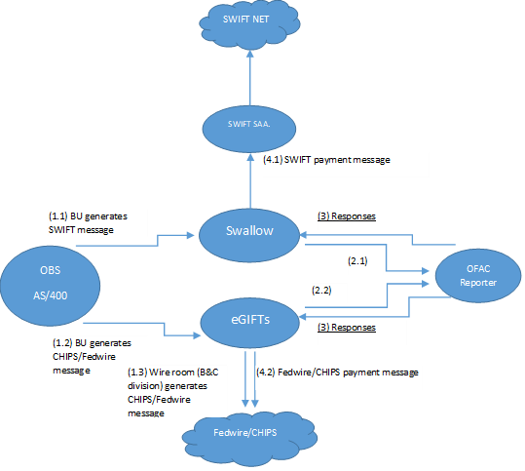

*Figure 5: Illustration of Outgoing payment messages from NY Branch*

**(Step 1)** Business unit (BU) will initiate a payment message to SWIFT/FedWire/CHIPS:

**(1.1)** BU (except wire room) generates SWIFT payment messages at OBS AS400 and sent to Swallow.

**(1.2)** BU (except wire room) generates CHIPS and FedWire payment message at OBS AS400 and sent to eGIFTS.

**(1.3)** Wire room generates CHIPS and Fedwire payment messages at eGifts.

**(Step 2)** SWALLOW or eGIFTS send messages to OFAC Reporter.

**(2.1)** Swallow to OFAC Reporter Connectivity, no format transformed.

**(2.2)** eGIFTS to OFAC Reporter Connectivity- mapped in Chapter V. eGIFTS data mapping.

**(Step 3)** Screening or investigated results will be returned to eGIFTS or Swallow for determining the next step of the flow. For example, if the message is not hit or hit but waived by the OFAC Reporter, eGIFTS will get the message for the wire to proceed its flow. If there was a true hit, then eGIFTS will instruct wire room staff to stop the payment.

**(Step 4)** Payment message will be sent to either SWIFT Net or FedWire/CHIPS

* + 1. **Non-Wire Messages**

Non-wire transactions such as checks, ACH, Trade Finance, etc., are entered manually into AS400.

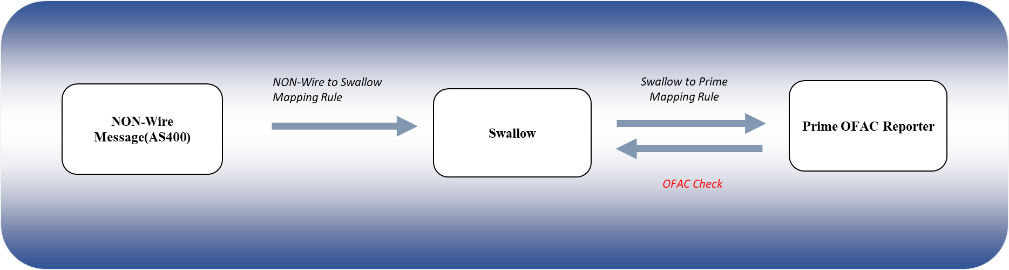

*Figure 6: Illustration of Non-Wire message flow at NY Branch*

**(Step 1)** Non-Wire messages are initiated in AS400 and sent through Swallow to PRIME OFAC Reporter for Realtime screening:

**(1.1)** Screening or investigated results will be returned to Swallow for determining the next step of the flow. For example, if the message is not hit or hit but waived by the OFAC Reporter, Swallow will get the message for the Non-Wire message to proceed its flow. If there was a true hit, then Swallow will instruct to stop the payment.

* + - 1. The following are considered Non-Wire messages: Dealing room activity, office expense payments, E-Loan, Loan, Book Transfer, Night Deposit, checks, ACH, Official check, Cashier check, Fast Transaction, GEB, Remittances (4E20 4E30), Import Letter of Credit, Documentary collection, CIF, Export document collection, Account Authorized signer (Connect Party), and CIF amendment. (*Please refer to OFAC Data Flow Excel*)
    1. **Non- USD and Non-Payment Wire Messages**

Non-USD and Non-Payment SWIFT messages sent through Swallow to PRIME OFAC Reporter for Realtime screening:

1. Screening or investigated results will be returned to Swallow for determining the next step of the flow. For example, if the message is not hit or hit but waived by the OFAC Reporter, Swallow will get the message for the Non-USD or Non-Payment message to proceed its flow. If there was a true hit, then Swallow will instruct to stop the payment.

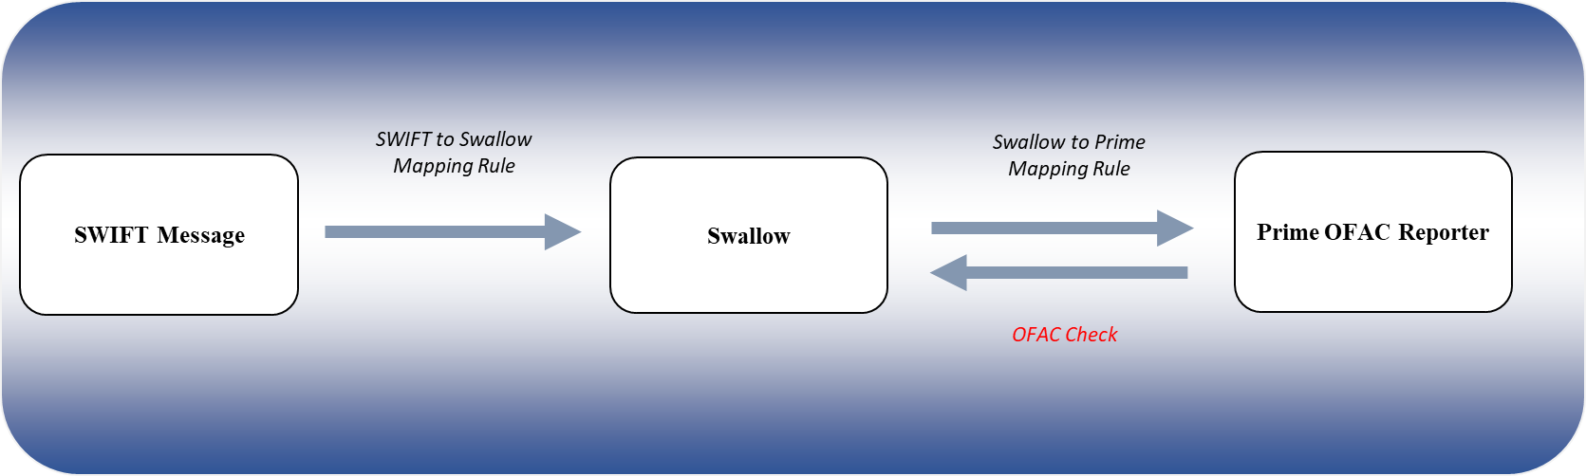

*Figure 7: Illustration of Non-USD or Non-Payment message flow at NY Branch*

* + 1. **Batch Filter Screening**

Batch Filter is a Sanction Filter program designed to provide the highest levels of configuration and performance. It has been designed to filter files of transactions or customer information where record counts can exceed 100 million records.

There are 3 Batch Filters being performed at NY Branch:

1. Sanction Customer (SANCCUST) screened daily
2. Non-Sanction Transaction (NSANCTXN) screened weekly
3. Non-Sanction Customer (NSANCCUS) screened weekly

All Batch Filter data is extracted from AS400 by PRIME OFAC Reporter for screening.

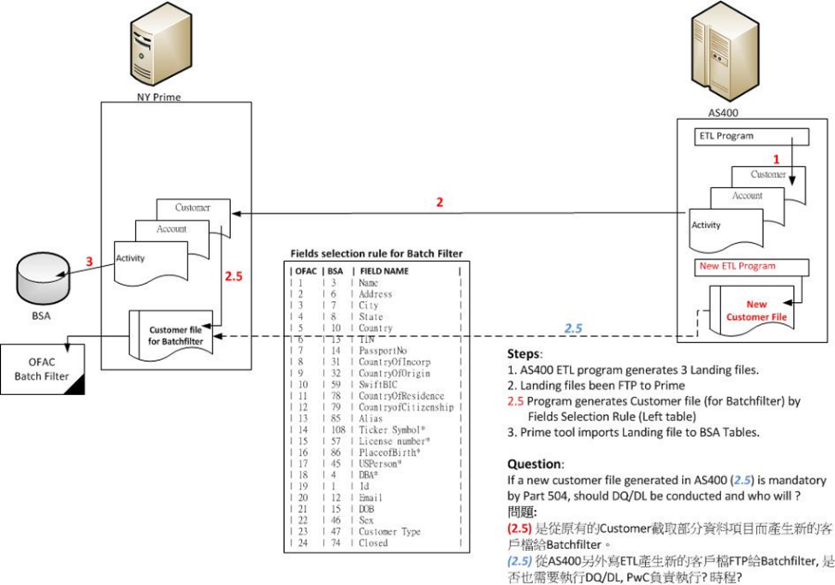

*Figure 8: Illustration of OFAC Reporter Batch Filter Screening process at NY Branch*



*Figure 9: Reporter Batch Filtering Customer File Speciation at NY Branch*

1. **Transaction Monitoring- BSA Reporter**
   1. Transaction Monitoring at Mega NYB Branch is performed monthly by PRIME BSA Reporter. The data flow is separated by wire data flow and Non-wire data flow.
      1. The three major tables used in BSA Reporter are:
         1. Activity
         2. Customer
         3. Account
   2. Transaction Monitoring Wire Data Flow
      1. All Wire transactions (SWIFT, FedWire, and CHIPS) are stored in the F9B00 (Transaction history) table. Then F9B00, Account, and Customer tables flow from AS400 to PRIME Activity table for screening.
      2. Customer Information flow from AS400 to PRIME Customer table.
      3. Account Information flow from AS400 to PRIME Account table.

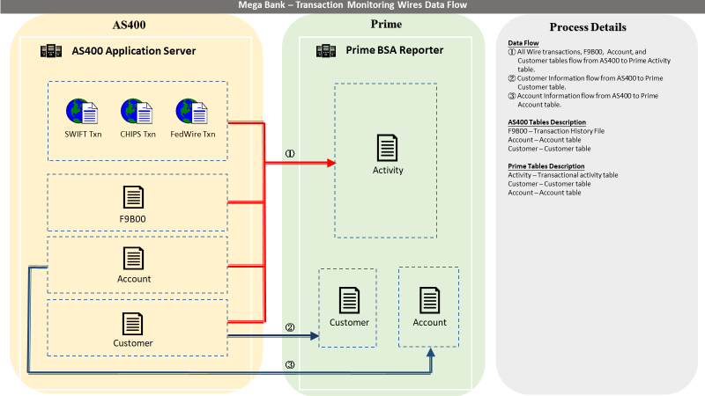

*Figure 11: Illustration of Mega Bank Transaction Monitoring Wires Data Flow*

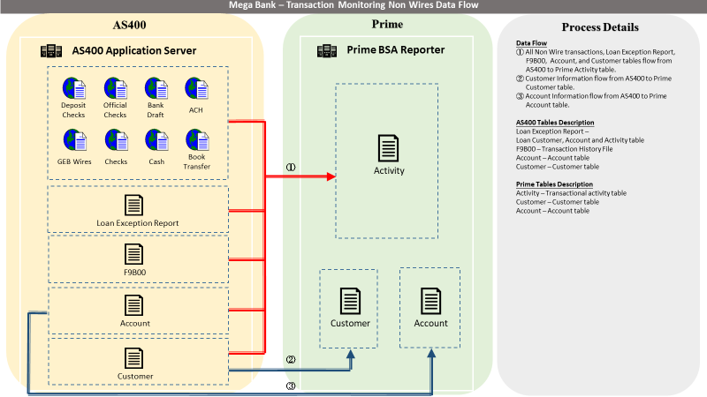

*Figure 12: Illustration of Mega Bank Transaction Monitoring Non-Wires Data Flow*

* 1. Transaction Monitoring Non-Wire Data Flow
     1. All Non-Wire transactions (Checks, ACH, Cash, Book Transfer, Foreign Exchange, etc.), Loan Exception Report(s), F9B00 (Transaction history), Account, and Customer tables flow from AS400 to PRIME Activity table for screening.
     2. Customer Information flow from AS400 to PRIME Customer table.
     3. Account Information flow from AS400 to PRIME Account table.

1. **eGIFTS**

There are three message formats received by eGIFTS, they are Chips, Fedwire and SWIFT, these samples are listed in the following:

* 1. **Wire Transaction Data Mapping to eGifts**

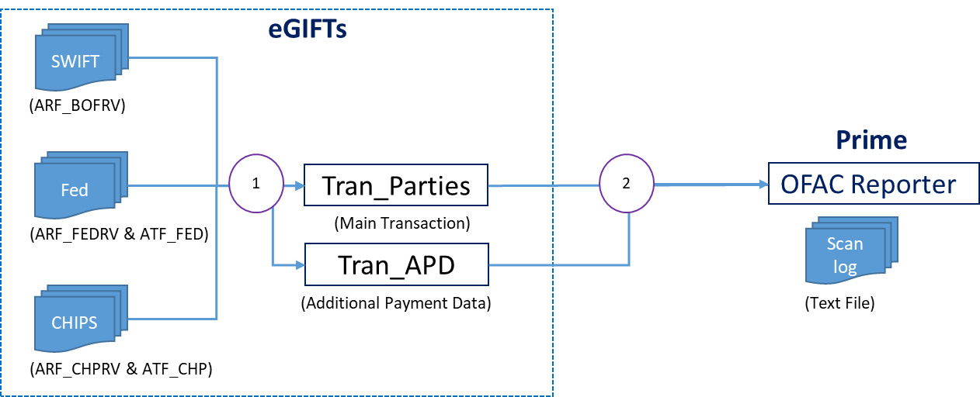 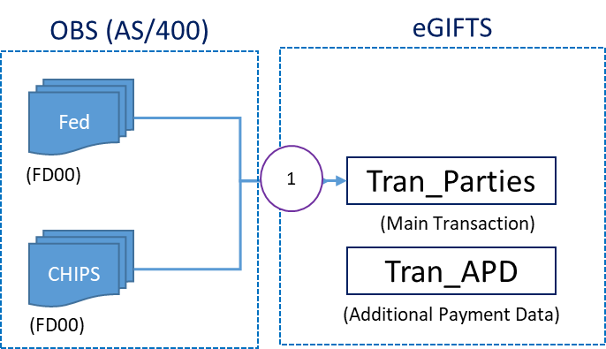

*Figure 13: Illustration of Incoming and Outgoing SWIFT/CHIPS/FedWire entering eGIFTS*

* + 1. **CHIPS and eGIFTS**
       1. Incoming raw CHIPS messages enter eGIFTS and is stored in table ARF_CHPRV.
          1. CHIPS message fields are mapped to TRAN_Parties based on message types.

Certain CHIPS messages will have additional payment data that is mapped to TRAN_APD.

* + - * 1. Detailed Mapping document *CHIPs to TRAN_PARTIES-20200219_V1* illustrating mapping rules and descriptions can be found in Appendix C.



* + - 1. Outgoing CHIPS messages from AS400 FD00 Table are mapped to eGIFTS TRAN_Parties table.
         1. Detailed mapping documents *AS400_FD00_to TRAN_PARTIES_BTR-20200215* and *AS400_FD00_to TRAN_PARTIES_CTR_CTP-20200215* can be found in Appendix C.





* + 1. **FedWire and eGIFTS**
       1. Incoming raw FedWire messages enter eGIFTS and is stored in table ARF_FEDRV.
          1. FedWire message fields are mapped to TRAN_Parties based on message types.
          2. Detailed Mapping document *FED to TRAN_PARTIES-20200219_V1.1* illustrating mapping rules and descriptions can be found in Appendix C.
       2. Outgoing FedWire messages from AS400 FD00 are mapped to eGIFTS TRAN_Parties table.
          1. Detailed mapping documents *AS400_FD00_to TRAN_PARTIES_BTR-20200215* and *AS400_FD00_to TRAN_PARTIES_CTR_CTP-20200215* can be found in Appendix C.



* + 1. **SWIFT and eGIFTS**
       1. Incoming raw SWIFT messages enter eGIFTS and is stored in table ARF_BOFRV.
          1. SWIFT message fields are mapped to TRAN_Parties based on message types.
          2. Detailed Mapping documents *SWIFT to TRAN_PARTIES-20200214_V1_MT200, SWIFT to TRAN_PARTIES-20200218_V1.1_MT103, and SWIFT to TRAN_PARTIES-20200218_V1.1_MT202 related* illustrating mapping rules and descriptions can be found in Appendix C.







* + - 1. Outgoing SWIFT messages are processed in SWALLOW, please refer to *Section VII.*
  1. **Data Mapping from eGIFTS to PRIME (OFAC Reporter)**
     1. eGIFTS is configured to transform all wire messages in an integrated format in Tran_Parties. 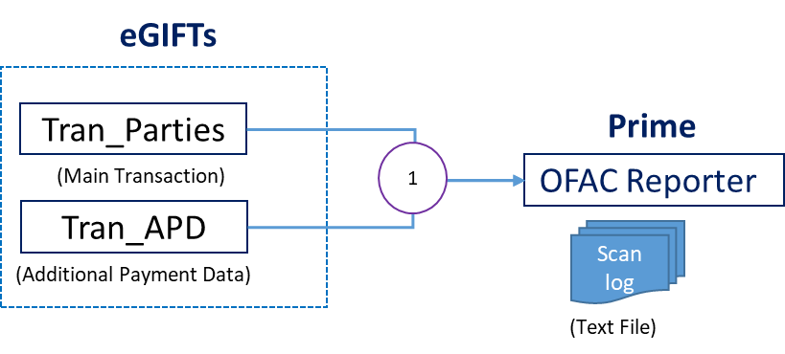

*Figure 14: Illustration of eGIFTS mapping to PRIME OFAC Reporter*

* + 1. The mapping table below will show the individual field names in the Egifts TRAN_PARTIES table mapped to the FedWire Tags in PRIME and their associated description.

|  |  |  |
| --- | --- | --- |
| **eGIFTs to Prime OFAC Screening Data Mapping Rule** | | |
| **Field Name in eGIFTs TRAN_PARTIES** | **Tags in Prime** | **Note** |
| SND_REF | {3320} | Sender Reference. |
| ORG_TYPE | {5000} | All originator fields ('ORG') are warpped in tag {5000}. |
| ORG_ID |
| ORG_NAME |
| ORG_ADDR_1 |
| ORG_ADDR_2 |
| ORG_ADDR_3 |
| OBIREF_1 | {6000} | All Originator to Beneficary Information fields ('OBIREF') are warpped in tag {6000}. |
| OBIREF_2 |
| OBIREF_3 |
| OBIREF_4 |
| BBIREF_1 | {6500} | All FI to FI Information fields ('BBIREF') are warpped in tag {6500}. |
| BBIREF_2 |
| BBIREF_3 |
| BBIREF_4 |
| BBIREF_5 |
| BBIREF_6 |
| IBK_TYPE | {4000} | All Intermediary FI fields ('IBK') are warpped in tag {4000}. |
| IBK_ID |
| IBK_NAME |
| IBK_ADDR_1 |
| IBK_ADDR_2 |
| IBK_ADDR_3 |
| BBK_TYPE | {4100} | All Beneficiary FI fields ('BBK') are warpped in tag {4100}. |
| BBK_ID |
| BBK_NAME |
| BBK_ADDR_1 |
| BBK_ADDR_2 |
| BBK_ADDR_3 |
| BNF_TYPE | {4200} | All Beneficiary fields ('BNF') are warpped in tag {4200}. |
| BNF_ID |
| BNF_NAME |
| BNF_ADDR_1 |
| BNF_ADDR_2 |
| BNF_ADDR_3 |
| OGB_TYPE | {5100} | All Originator FI fields ('OGB') are warpped in tag {5100}. |
| OGB_ID |
| OGB_NAME |
| OGB_ADDR_1 |
| OGB_ADDR_2 |
| OGB_ADDR_3 |
| INST_TYPE | {5200} | All Intermediary FI fields ('INST') are warpped in tag {5200}. |
| INST_ID |
| INST_NAME |
| INST_ADDR_1 |
| INST_ADDR_2 |
| INST_ADDR_3 |
| BNF_REF | {4320} | Reference for Beneficiary. |
| IRN | <RequestRef> | eGIFTs system generated. Primary Key. |
| BRANCH_CODE | <Branch> | eGIFTs system generated. |
| DEPT_CODE | <Dept> | eGIFTs system generated. |
| FUNDS_LOCAL_CURR | {2000} | All transaction amount fields ('CURR', 'AMT') are warpped in tag {2000}. |
| FUNDS_CREDIT_AMT |
| SND_BANK_ID | {3100} | Sender DI. |
| RCV_BANK_ID | {3400} | Receiver DI. |
| IBK2_TYPE | {4300} | All Secondary Intermediary FI fields ('IBK2') are warpped in tag {4300}. *This is Not a tag in Standard Fedwire Format but produced by eGIFTs. |
| IBK2_ID |
| IBK2_NAME |
| IBK2_ADDR_1 |
| IBK2_ADDR_2 |
| IBK2_ADDR_3 |
| APD_IBK_TYPE | {7400} | All Intermeiary IF fields in COV messages ('APD_IBK') are warpped in tag {7400}. *This is equivalent to tag {7056} (Sequence B 56a Intermediary Institution) in Standard Fedwire Format. |
| APD_IBK_ID |
| APD_IBK_NAME |
| APD_IBK_ADDR_1 |
| APD_IBK_ADDR_2 |
| APD_IBK_ADDR_3 |
| APD_BBK_TYPE | {7410} | All Beneficiary IF fields in COV messages ('APD_BBK') are warpped in tag {7410}. *This is Not a tag in Standard Fedwire Format but produced by eGIFTs. |
| APD_BBK_ID |
| APD_BBK_NAME |
| APD_BBK_ADDR_1 |
| APD_BBK_ADDR_2 |
| APD_BBK_ADDR_3 |
| APD_BNF_TYPE | {7420} | All Beneficiary fields in COV messages ('APD_BNF') are warpped in tag {7420}. *This is equivalent to tag {7059} (Sequence B 59a Beneficiary Customer) in Standard Fedwire Format. |
| APD_BNF_ID |
| APD_BNF_NAME |
| APD_BNF_ADDR_1 |
| APD_BNF_ADDR_2 |
| APD_BNF_ADDR_3 |
| APD_ORG_TYPE | {7500} | All Beneficiary fields in COV messages ('APD_ORG') are warpped in tag {7500}. *This is equivalent to tag {7050} (Sequence B 50a Ordering Customer) in Standard Fedwire Format. |
| APD_ORG_ID |
| APD_ORG_NAME |
| APD_ORG_ADDR_1 |
| APD_ORG_ADDR_2 |
| APD_ORG_ADDR_3 |
| APD_OGB_TYPE | {7510} | All Beneficiary fields in COV messages ('APD_OGB') are warpped in tag {7510}. *This is equivalent to tag {7052} (Sequence B 52a Ordering Institution) in Standard Fedwire Format. |
| APD_OGB_ID |
| APD_OGB_NAME |
| APD_OGB_ADDR_1 |
| APD_OGB_ADDR_2 |
| APD_OGB_ADDR_3 |
| APD_OBIREF_1 | {7600} | All Originator to Beneficary Information fields in COV messages ('APD_OBIREF') are warpped in tag {7600}. *This is equivalent to tag {7070} (Sequence B 70 Remittance Information) in Standard Fedwire Format. |
| APD_OBIREF_2 |
| APD_OBIREF_3 |
| APD_OBIREF_4 |
| APD_BBIREF_1 | {7650} | All FI to FI Information fields in COV messages ('APD_BBIREF') are warpped in tag {7650}. *This is equivalent to tag {7072} (Sequence B 72 Sender to Receiver Information) in Standard Fedwire Format. |
| APD_BBIREF_2 |
| APD_BBIREF_3 |
| APD_BBIREF_4 |
| APD_BBIREF_5 |
| APD_BBIREF_6 |
| ADDENDA_CNT | {9200} | *This is Not a tag in Standard Fedwire Format. |
|  |  |  |

* + 1. Once OFAC Reporter completes its scan, a scan log in the format of a text file will be returned to eGIFTS to indicate whether the transaction can proceed.

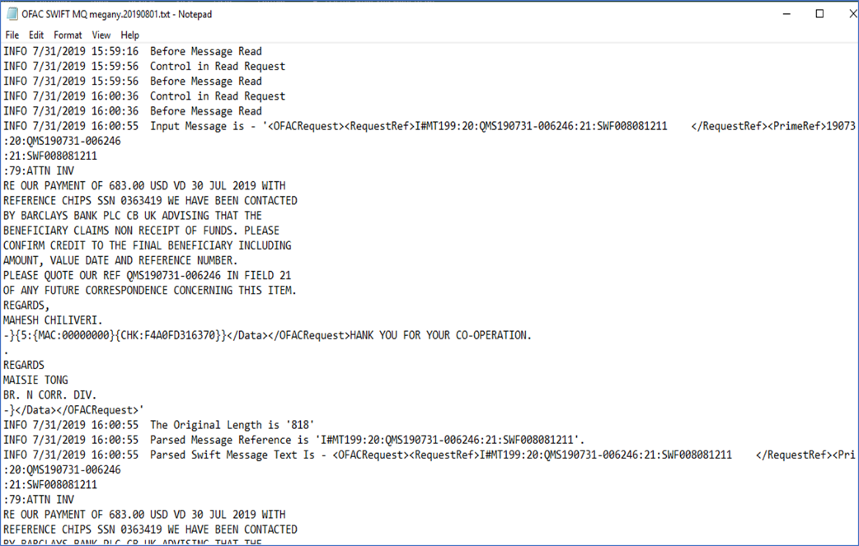

*Figure 15: Illustration of PRIME Log for SWIFT Message*

* 1. **Data Mapping from eGIFTS to AS400**

Fields in eGIFTS Tran_ Parties and Tran_APD are mapped to AS400’s FFCDB table.

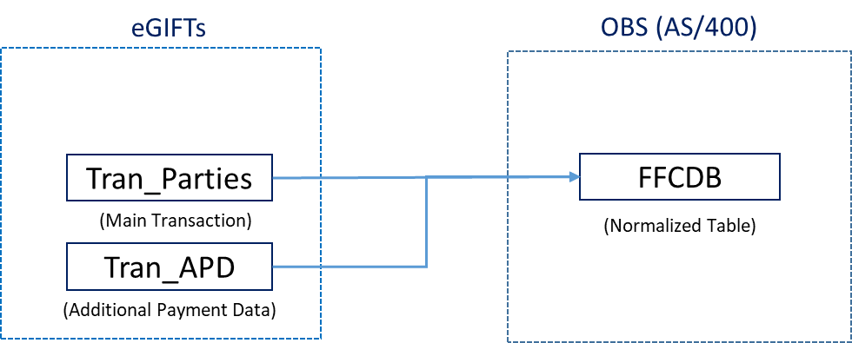

*Figure 16: Illustration of eGIFTS mapping to AS400*

* + 1. CHIPS
       1. Incoming and outgoing CHIPS messages from table Tran_Parties will be mapped to FFCDB table.
          1. Detailed Mapping document *eGIFTS Data Mapping to AS400 20200211(CHIPSin)* illustrating filter criteria and descriptions can be found in Appendix C.



* + - * 1. Detailed Mapping document *eGIFTS Data Mapping to AS400 by SAM 20200211_Rita(CHIPSout)* illustrating filter criteria and descriptions can be found in Appendix C.



* + 1. FedWire
       1. Incoming and Outgoing FedWire messages from tables Tran_Parties will be mapped to FFCDB table.
          1. Detailed Mapping document *eGIFTS Data Mapping to AS400 20200211(FEDin)* illustrating filter criteria and descriptions can be found in Appendix C.



* + - * 1. Detailed Mapping document *eGIFTS Data Mapping to AS400 20200211(FEDin)* illustrating filter criteria and descriptions can be found in Appendix C.



* + 1. SWIFT
       1. Incoming SWIFT messages from tables Tran_Parties will be mapped to FFCDB table.
          1. Detailed Mapping document *eGIFTS Data Mapping to AS400 20200211(SWIFT)* illustrating filter criteria and descriptions can be found in Appendix C.



1. **SWALLOW**

Incoming SWIFT Non- USD and Non- Payment messages flow through SWALLOW to PRIME OFAC Reporter for real time screening. After messages are screened, PRIME will send a message to SWALLOW and SWALLOW will forward the message to AS400.

SWALLOW

SWIFT

PRIME

AS400

1

2.11

2.21

3.11

3.21

4.11

4.21

*Figure 13: Illustration of Mega Bank Swallow Data flow/mapping chart*

* 1. **SWIFT and SWALLOW**

|  |  |
| --- | --- |
| 1. **Incoming and Outgoing SWIFT raw message** | **SWIFT Block Description** |
| {1:F01ICBCUS60AXXX0064000152}{2:O1031330200130ICBCHKH0AXXX02080009042001292130N}{3:{121:a34cfeff-7c48-48f6-b196-b25060f25e88}}{4:  :20:HKGTOAP25TEST2  :23B:CRED  :32A:191227USD1000,00  :33B:USD1000,00  :50F:/96511006188  1/TEST 000006188 NAME name aaa bbb  2/TEST 000006188 ADDR1  2/TEST 000006188 ADDR2  3/HK/AA,BB  :54A:BOFAUS3N  :57A:ICBCUS33  :59F:/123  1/TEST 000006188 BNF NAME  1/T0669 0554 1579  2/IRAN  3/TW/IRAN  :71A:SHA  -}{5:{MAC:00000000}{CHK:8D237168D9DB}{TNG:}}{S:{SAC:}{COP:S}} | {1:Basic Header Block}  {2:Applicatin Header Block}  {3:User Header Block}  {4:Text Block or body}  {5:Trailer Block} |

* 1. **SWALLOW and PRIME**

|  |  |
| --- | --- |
| **SWIFT incoming received by SWALLOW and sent to PRIME (2.11)**  *Located in SWALLOW LOG FILE: D:\NYAwallow\logs\svc\Obs-swa-iosvc-aml-sw.log* | **PRIME receive SWIFT incoming from SWALLOW (2.21)**  *PRIME LOG FILE: OFAC NYA SWIFT Sanction mega.log* |
| <OFACRequest><RequestRef>I#MT103:20:HKGTOAP25TEST2 </RequestRef><PrimeRef>200130133032629339552I0</  PrimeRef><Dept>BUSI</Dept><Branch>LAC</Branch><Data>RECEIVER:ICBCHKH0 COUNTRY:HK {1:F01ICBCUS60AXXX0064000152}{2:O1031330200130ICBCHKH0AXXX02080009042001292130N}{3:{121:a34cfeff-7c48-48f6-b196-b25060f25e88}}{4:  :20:HKGTOAP25TEST2  :23B:CRED  :32A:191227USD1000,00  :33B:USD1000,00  :50F:/96511006188  1/TEST 000006188 NAME name aaa bbb  2/TEST 000006188 ADDR1  2/TEST 000006188 ADDR2  3/HK/AA,BB  :54A:BOFAUS3N  :57A:ICBCUS33  :59F:/123  1/TEST 000006188 BNF NAME  1/T0669 0554 1579  2/IRAN  3/TW/IRAN  :71A:SHA  -}{5:{MAC:00000000}{CHK:8D237168D9DB}{TNG:}}</Data></OFACRequest> | <OFACRequest><RequestRef>I#MT103:20: </RequestRef><PrimeRef>200130133032629339552I0</PrimeRef><Dept>BUSI</Dept><Branch>LAC</Branch><Data>RECEIVER:ICBCHKH0 COUNTRY:HK {1:F01ICBCUS60AXXX0064000152}{2:O1031330200130ICBCHKH0AXXX02080009042001292130N}{3:{121:a34cfeff-7c48-48f6-b196-b25060f25e88}}{4:  :20:HKGTOAP25TEST2  :23B:CRED  :32A:191227USD1000,00  :33B:USD1000,00  :50F:/96511006188  1/TEST 000006188 NAME name aaa bbb  2/TEST 000006188 ADDR1  2/TEST 000006188 ADDR2  3/HK/AA,BB  :54A:BOFAUS3N  :57A:ICBCUS33  :59F:/123  1/TEST 000006188 BNF NAME  1/T0669 0554 1579  2/IRAN  3/TW/IRAN  :71A:SHA  -}{5:{MAC:00000000}{CHK:8D237168D9DB}{TNG:}}</Data></OFACRequest> |

PRIME Field name, Sample, and Value description

|  |  |  |
| --- | --- | --- |
| **Field Name/ XML Tags** | **Sample** | **Value description** |
| <RequestRef> | I#MT103:20:HKGTOAP25TEST2 | I:Incoming,O:Outgoing  MT103🡪SWIFT Message Type :20:🡪 SWIFT Tag20 |
| <PrimeRef> | 200130133032629339552I0 | SWALLOW generated unique id |
| <Dept> | BUSI  CORR | BUSI:Business Department  CORR:Correspondent Department |
| <Branch> | NYA,LAC,CGO,SVB | NYA: New York  LAC: Losangel  CGO: Chicago  SVB: Sanjose |
| <Data> | RECEIVER:ICBCHKH0 COUNTRY:HK | Retreive BIC and ISO-3166 country code from SWIFT Block 2  {2:O1031330200130ICBCHKH0AXXX02080009042001292130N} |
| <Data> | {1:F01ICBCUS60AXXX0064000152}{2:O1031330200130ICBCHKH0AXXX02080009042001292130N}{3:{121:a34cfeff-7c48-48f6-b196-b25060f25e88}}{4:  :20:HKGTOAP25TEST2  :23B:CRED  :32A:191227USD1000,00  :33B:USD1000,00  :50F:/96511006188  1/TEST 000006188 NAME name aaa bbb  2/TEST 000006188 ADDR1  2/TEST 000006188 ADDR2  3/HK/AA,BB  :54A:BOFAUS3N  :57A:ICBCUS33  :59F:/123  1/TEST 000006188 BNF NAME  1/T0669 0554 1579  2/IRAN  3/TW/IRAN  :71A:SHA  -}{5:{MAC:00000000}{CHK:8D237168D9DB}{TNG:}} | Completed Data of SWIFT from Blok 1 to Block 5 |

(3.) PRIME sends screening result to Swallow

|  |  |
| --- | --- |
| **PRIME sends result of screening to SWALLOW (3.11)**  *PRIME LOG FILE: OFAC NYA SWIFT Sanction mega.log* | **SWALLOW receives result from PRIME (3.21)**  *SWALLOW LOG FILE: D:\NYAwallow\logs\svc\Obs-swa-iosvc-aml-sw.log* |
| Final Message = <OfacRequestAndResponse>  <OfacHeader>  <SystemName>Prime OFAC-Reporter</SystemName>  <Date>1/30/2020 13:30:33</Date>  <PrimeRef>200130133032629339552I0</PrimeRef>  <RequestRef>I#MT103:20:HKGTOAP25TEST2</RequestRef>  <MatchCount>1</MatchCount>  <Matches>  <Match>  <MatchName>IRAN</MatchName>  <OriginalSDNName>IRAN</OriginalSDNName>  <MatchText>IRAN</MatchText>  <Title></Title>  <Program>IRAN</Program>  <Type>other</Type>  <Remarks>SANCTIONED COUNTRY</Remarks>  <MatchInfo> </MatchInfo>  </Match>  </Matches>  </OfacHeader>  <OFACRequest><RequestRef>I#MT103:20:HKGTOAP25TEST2 </RequestRef><PrimeRef>200130133032629339552I0</PrimeRef><Dept>BUSI</Dept><Branch>LAC</Branch><Data>{1:F01ICBCUS60AXXX0064000152}{2:O1031330200130ICBCHKH0AXXX02080009042001292130N}{3:{121:a34cfeff-7c48-48f6-b196-b25060f25e88}}{4:  :20:HKGTOAP25TEST2  :23B:CRED  :32A:191227USD1000,00  :33B:USD1000,00  :50F:/96511006188  1/TEST 000006188 NAME name aaa bbb  2/TEST 000006188 ADDR1  2/TEST 000006188 ADDR2  3/HK/AA,BB  :54A:BOFAUS3N  :57A:ICBCUS33  :59F:/123  1/TEST 000006188 BNF NAME  1/T0669 0554 1579  2/IRAN  3/TW/IRAN  :71A:SHA  -}{5:{MAC:00000000}{CHK:8D237168D9DB}{TNG:}}</Data></OFACRequest>  </OfacRequestAndResponse> | recv:<OfacRequestAndResponse>  <OfacHeader><OfacHeader>  <SystemName>Prime OFAC-Reporter</SystemName>  <Date>1/30/2020 13:30:33</Date>  <PrimeRef>200130133032629339552I0</PrimeRef>  <RequestRef>I#MT103:20:HKGTOAP25TEST2</RequestRef>  <MatchCount>1</MatchCount>  <Matches>  <Match>  <MatchName>IRAN</MatchName>  <OriginalSDNName>IRAN</OriginalSDNName>  <MatchText>IRAN</MatchText>  <Title></Title>  <Program>IRAN</Program>  <Type>other</Type>  <Remarks>SANCTIONED COUNTRY</Remarks>  <MatchInfo> </MatchInfo>  </Match>  </Matches>  </OfacHeader>  <OFACRequest><RequestRef>I#MT103:20:HKGTOAP25TEST2 </RequestRef><PrimeRef>200130133032629339552I0</PrimeRef><Dept>BUSI</Dept><Branch>LAC</Branch><Data>{1:F01ICBCUS60AXXX0064000152}{2:O1031330200130ICBCHKH0AXXX02080009042001292130N}{3:{121:a34cfeff-7c48-48f6-b196-b25060f25e88}}{4:  :20:HKGTOAP25TEST2  :23B:CRED  :32A:191227USD1000,00  :33B:USD1000,00  :50F:/96511006188  1/TEST 000006188 NAME name aaa bbb  2/TEST 000006188 ADDR1  2/TEST 000006188 ADDR2  3/HK/AA,BB  :54A:BOFAUS3N  :57A:ICBCUS33  :59F:/123  1/TEST 000006188 BNF NAME  1/T0669 0554 1579  2/IRAN  3/TW/IRAN  :71A:SHA  -}{5:{MAC:00000000}{CHK:8D237168D9DB}{TNG:}}</Data></OFACRequest>  </OfacRequestAndResponse> |

* 1. **SWALLOW and AS400** 
     1. (4.1 and 4.2) Swallow table: SWMTEXT to AS400 File: FSWTRCA is shown below.

|  |  |
| --- | --- |
| Swallow table: SWMTEXT | AS400 table: FSWTRCA |
| Column: MESG_DATA | Column: FD2SA_SWIFT_DATA |
| {1:F01ICBCUS33AXXX3173702527}{2:O1031655200207ICBCTHBKAXXX80927476772002070455N}{3:{121:a749c3f3-563d-48cc-b376-ad46b74a2e32}}{4:  :20:BKKTOREM0120/20  :23B:CRED  :32A:200207USD2866,00  :50F:/0580200046  1/CTCI (THAILAND) CO.,LTD.  2/825,PHAIROJKIJJA TOWER,19F.,  2/DEBARATANA K.M.4 RD.,BANGNANUA,  3/TH/BANGKOK  :59F:/2020100-31799  1/INTERNATIONAL BUSINESS GROUP  1/CHUNGHWA TELECOM CO.,LTD.  2/31,AI-KUO EAST ROAD TAIPEI,TAIWAN  3/TW  :70:IPVPN SERVICE FEE  INVOICE NO.THAB/JAN/2020/0001  :71A:SHA  -}{5:{MAC:00000000}{CHK:07387BE06398}}{S:{SAC:}{COP:S}} | {1:F01ICBCUS33AXXX3173702527}{2:O1031655200207ICBCTHBKAXXX80927476772002070455N}{3:{121:a749c3f3-563d-48cc-b376-ad46b74a2e32}}{4: :20:BKKTOREM0120/20 :23B:CRED :32A:200207USD2866,00 :50F:/0580200046 1/CTCI (THAILAND) CO.,LTD. 2/825,PHAIROJKIJJA TOWER,19F., 2/DEBARATANA K.M.4 RD.,BANGNANUA, 3/TH/BANGKOK :59F:/2020100-31799 1/INTERNATIONAL BUSINESS GROUP 1/CHUNGHWA TELECOM CO.,LTD. 2/31,AI-KUO EAST ROAD TAIPEI,TAIWAN 3/TW :70:IPVPN SERVICE FEE INVOICE NO.THAB/JAN/2020/0001 :71A:SHA -}{5:{MAC:00000000}{CHK:07387BE06398}}{S:{SAC:}{COP:S}} |

1. **AS400/ PRIME**
   1. **AS400 to PRIME Data Mapping**
      1. AS400 raw data is transformed by the ETL process into 3 landing files (Activity, Account and Customer) in the format readable by PRIME Compliance Suit.
      2. ETL (Extract, Transform, Load) Procedures at Mega NYBB
         1. ETL procedures are defined by New York Branch EDC division (IT) on daily checking process both for PRIME BSA Reporter and PRIME OFAC Reporter. Source system (AS400) provides daily execution results for generating landing files to New York Branch.
      3. **PRIME BSA Reporter**
         1. Activity Wire ETL
            1. Detailed mapping can be found in Activity_Wire_V17 (Excel)

Source Data (AS400) is transformed and filtered (Blue) to PRIME data elements (Black)

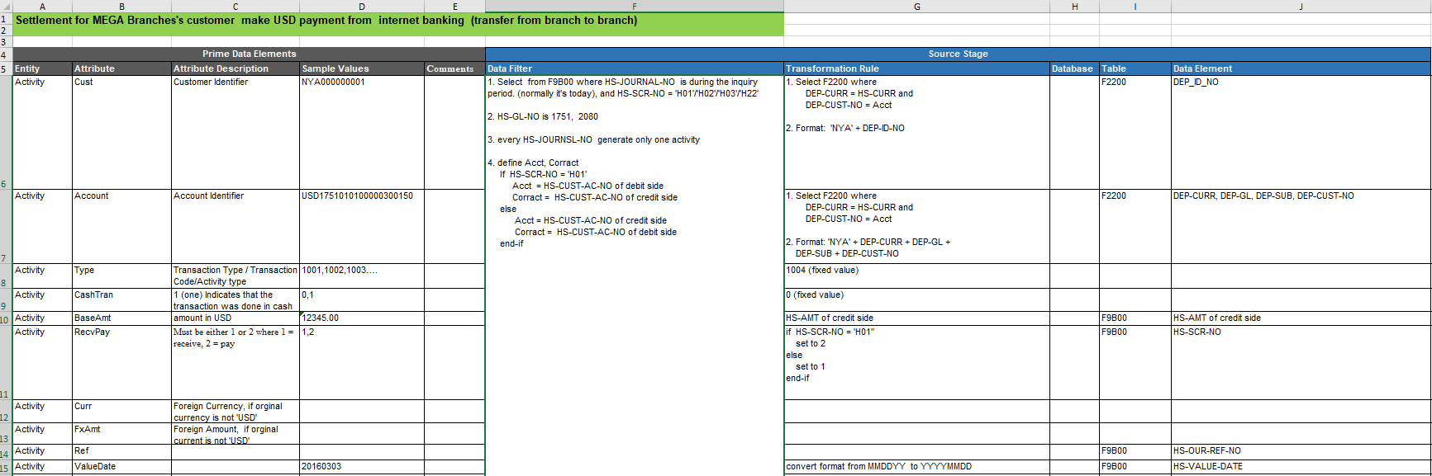

* + - 1. Account ETL
         1. Detailed mapping can be found in Account_v3 (Excel)

Source Data (AS400) tables F2200, F3200, and F9S00 are transformed and filtered (Blue) to PRIME data format.

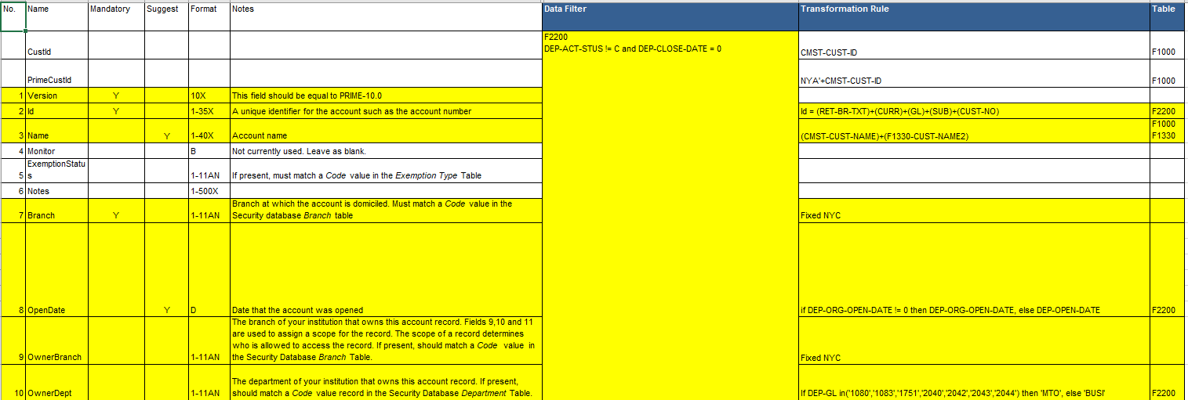

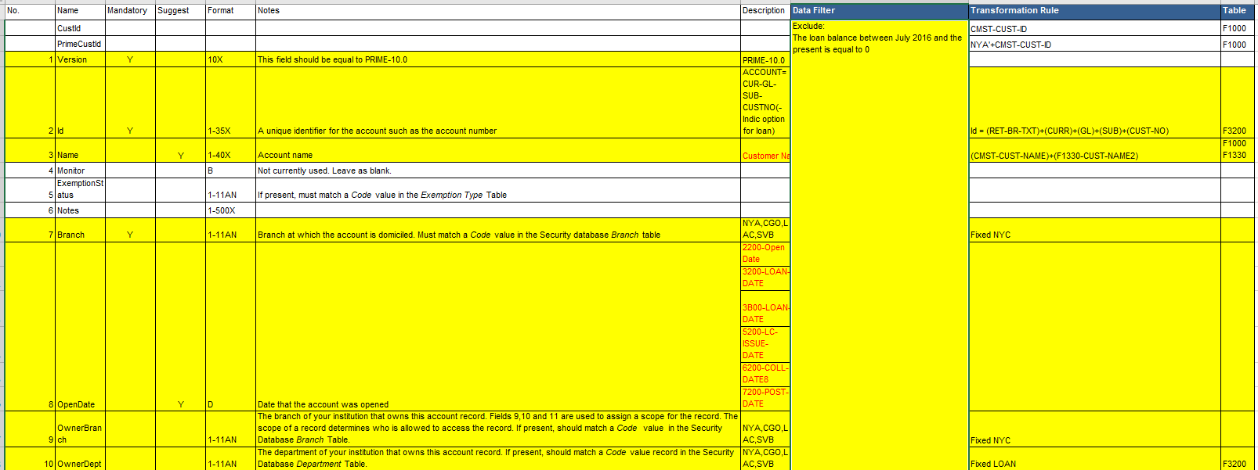



* + - 1. Customer ETL
         1. Detailed mapping can be found in Customer_v5 (Excel)
         2. Source Data (AS400) is transformed and filtered (Blue) to PRIME data elements (Black)

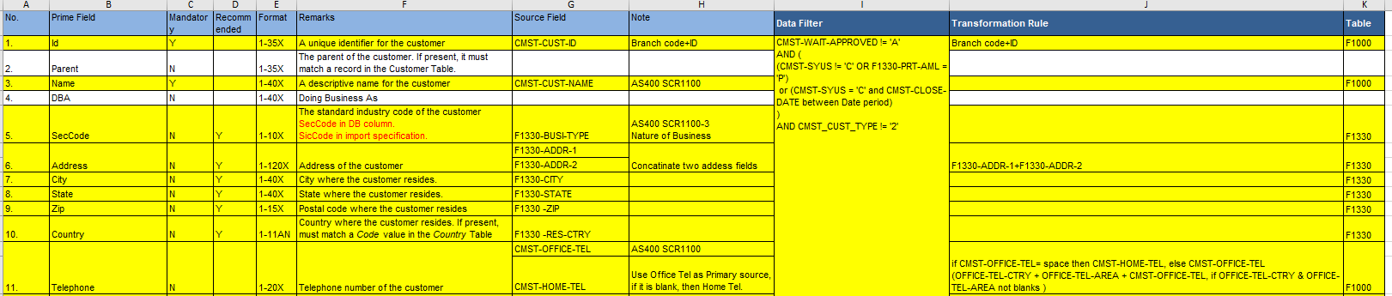

* + - 1. Activity Non-Wire ETL
         1. All Non-wire transactions, Loan Exception Reports, F9B00 Table, Account and Customer tables flow from AS400 to PRIME Compliance Suit.
         2. Non-Wire Activity tables contain two parts:

Activity_NonWire_Part1_v7 (excel) contains Cash, ACH, ACH_New, Official checks, Deposit checks, and regular checks.

Source Data (AS400) is transformed and filtered (Blue) to PRIME data elements (Black)

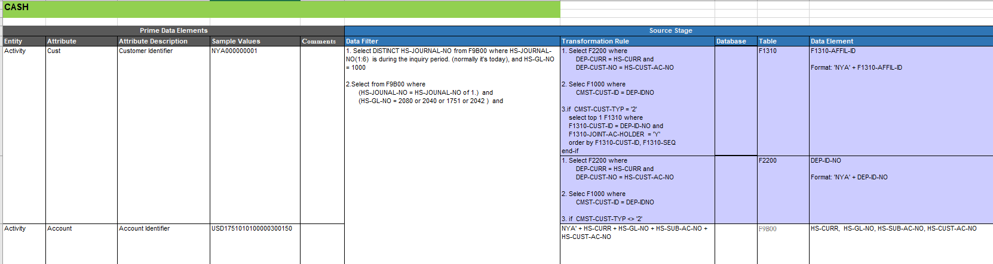

Activity_NonWire_Part2_v9(excel) contains Bank drafts, Bill collection, Book transfers, and Foreign exchange.

Source Data (AS400) is transformed and filtered (Blue) to PRIME data elements (Black)

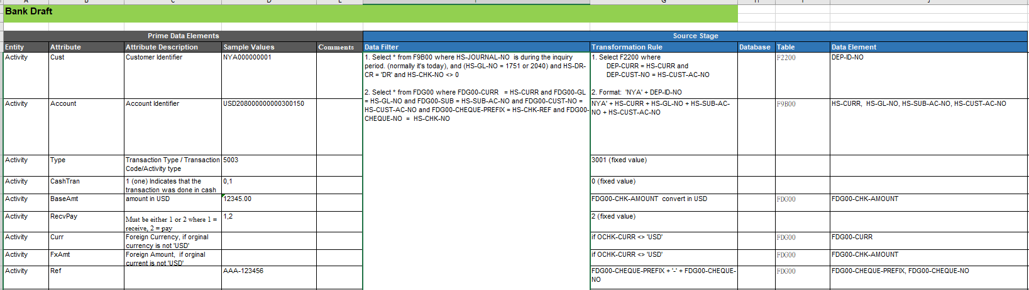

* + - 1. Loan Exception Reports ETL
         1. Loan exception reports are provided to generate loan specific cases, which could not be set by PRIME BSA Reporter for its restriction on creating “outside the box” scenarios. Thus, Laon Exception reports are designed to screen outside of PRIME and loaded into BSA cases directly. The mapping is different from the predefined landing files as it generates cases directly to the Case Management module.

More details on Loan Exception Reports ETL can be found in *Mega NYBB Loan Exception Report-ETL* (Excel).



* + 1. **OFAC Reporter**
       1. Data mapping occurs when batch filtering files are extracted from source system (AS400) to Prime OFAC Reporter.
       2. Batch Files for Batch Screening
          1. OFAC Customer ETL

Customer Source Data from (AS400) is transformed and filtered to PRIME. Mapping details can be found in the *OFAC_Customer_20190628* excel.

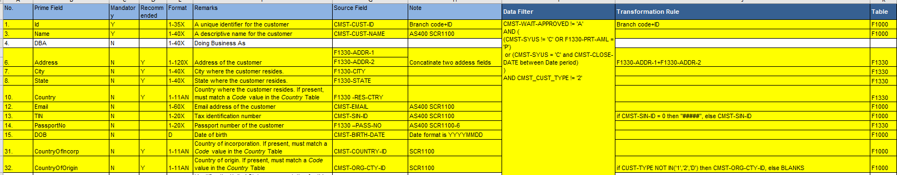

* + - * 1. PEPs Customer ETL

PEPs Source Data from (AS400) is transformed and filtered to PRIME. Mapping details can be found in *PEPs_Customer_20190628* excel.

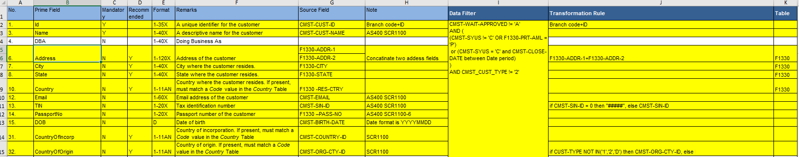

* + - * 1. Non- Sanction ETL

Non-Sanction Source Data from (AS400) comes from multiple fields within source tables. Mapping details can be found in *NSANCTXN_20181029* excel.

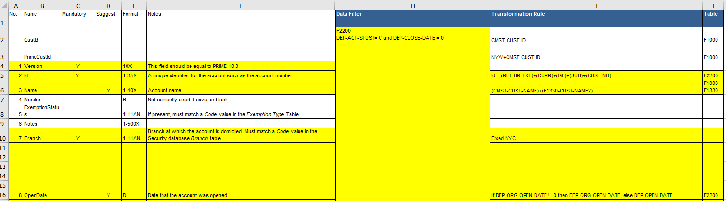

1. **Appendix**
   1. **Assumptions and Limitations**
      1. **Specifications**
         1. 
         2. 
         3. 
      2. **Inclusion and Exclusion**
         1. 
   2. **Sanction Screening Data Flow**
      1. 
   3. **Transaction Monitoring Data Flow**
      1. 
   4. **eGIFTS**
      1. 
      2. 
      3. 
      4. 
      5. 
      6. 
      7. 
      8. 
   5. **Swallow**

* + 1. 
  1. **AS400/PRIME**
     1. **OFAC Reporter**
        1. 
        2. 
        3. 
        4. 
     2. **Batch Filter**
        1. 
     3. **Landing Files**
        1. 
     4. **BSA Reporter**
        1. 
        2. 
        3. 
        4. 
        5. 